Setting up the Unity project

For Sprint 1 we did not have any Continuous Integration set up for building our Unity project, so manual building of the project was done. This requires setting up unity on your system.

Download unity from the Unity store ( <https://store.unity.com/> ). We are using the personal edition version 5.4.2f2 which is free up to the first $100,000.

Install and set up your unity account. When you start unity, it will prompt you to create a new project. Select a name and location to store the project and name the project appropriately. Make sure that the project is set up as a 2D project. Note that 2D mode is not vital, but when you start in 2D mode the environment is set up for the creation of 2D games.

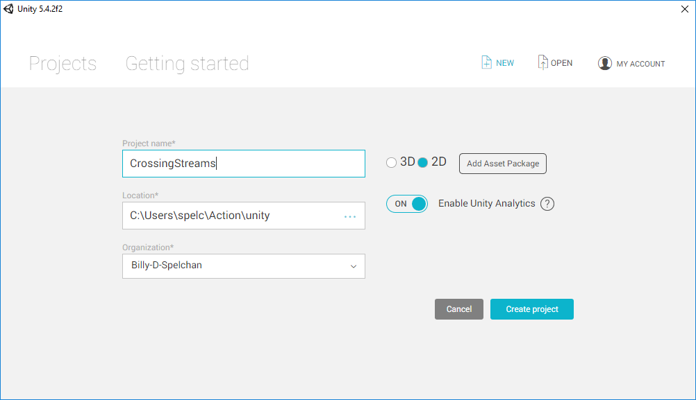

Make sure that meta files are visible so that you can use a repository such as git. This is done using Edit->Project Settings->Editor Settings. Set version control mode to visible meta files.

Use File->Save Project to make sure the project is created.

Copy the files from the git repository’s Unity/Asset directory into the assets directory within the project.

Refresh the assets folder in Unity (right click Assets folder in project folder, select refresh).

If the repository is up to date and no issues should be able to run. Keeping the repository up to date was one of our issues for Sprint 1 but we hope to get this under control for sprint 2.